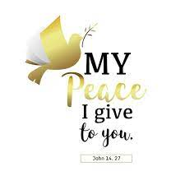


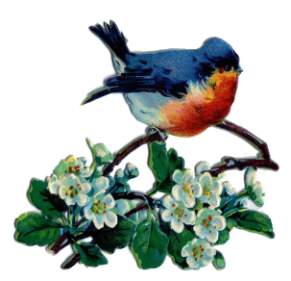


October/November/December 2025
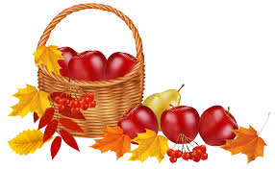

Our ministry vision for the Virginia Annual Conference is “to be disciples of Jesus Christ who are lifelong learners, who influence others to serve.”

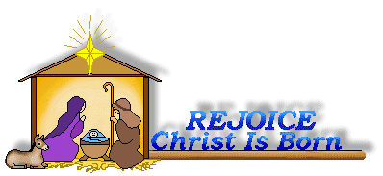

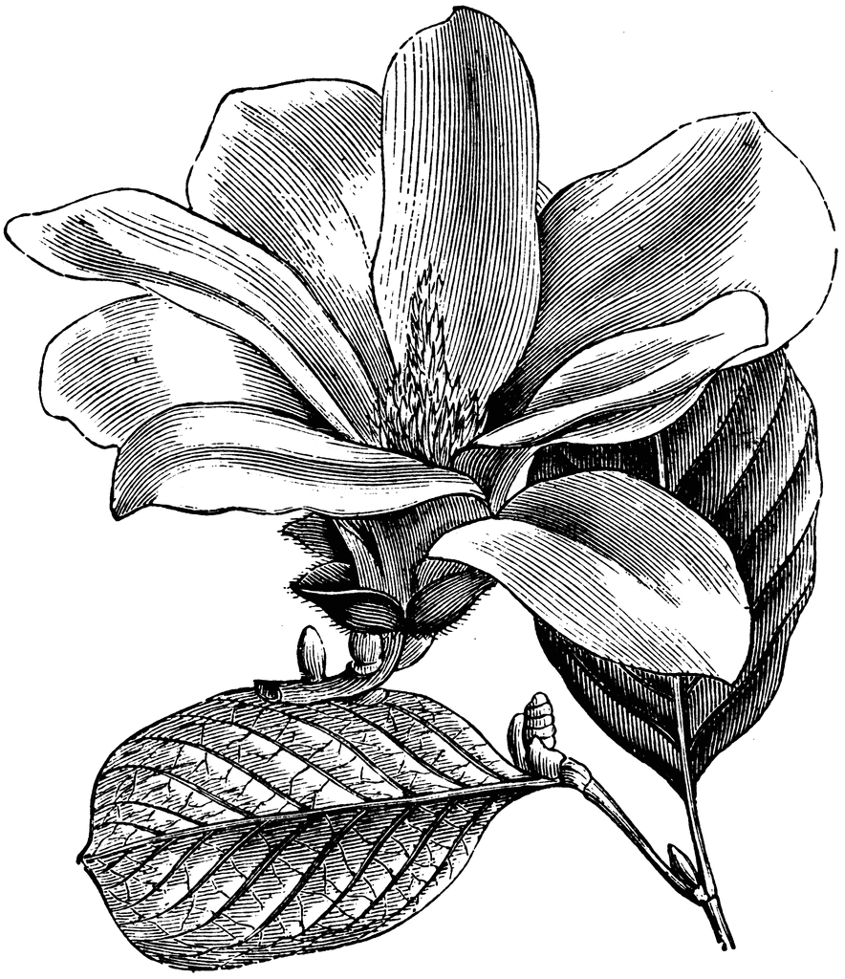


From Pastor Adam

“Gratitude is Changing Lenses”

“Acknowledging the good that you already have in your life is the foundation for all abundance.” ~ Eckhart Tolle

"We often take for granted the very things that most deserve our gratitude." ~ Cynthia Ozick

“Gratitude looks to the Past and love to the Present; fear, avarice, lust, and ambition look ahead.”
~ C.S. Lewis

If anything can be said of human beings, it is that we are consistently forward-looking: we plan, we prepare, we anticipate. We are quite often spending our days preparing for what tomorrow might bring. Of course, this is a necessity, and a noble one at that. However, there also lies the risk that we postpone the full enjoyment of the present for some future we are ever-building. Sometimes we can postpone joy for some future date, saying to ourselves things like: “When I graduate from college, then my life will truly begin; when I get my first job, then my life will truly begin, when I get married and have a family, my life will truly begin; when I get this mortgage paid off, my life will truly begin; when I write the last college tuition check, then my life will truly begin; when I retire, my life will truly begin; when I have enough of everything, then my life will truly begin.”
There is something important about paying attention to the gifts of God we have received in days gone by, and the gifts of God we enjoy presently, that inspires gratitude in a way that we cannot experience when we are banking our whole existence on the future. In short, gratitude is a matter of changing lenses, so that our focus can be redirected to the discovery and celebration of the good things we already have in the active present and the recent past. Gratitude is the most liberating and life-giving sentiment. As we look to Thanksgiving Day, that great national day of gratitude, may we have our “lenses” focused on the treasures hiding right under our noses and every blessing along the way.
And may we have the courage to let the “future be the future” as we leave those things to mercy and providence of God.
God bless you my friends, Adam

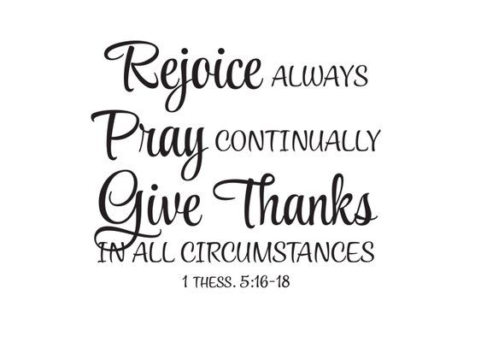


Save the Date
You are cordially invited to attend….
The 100th birthday party of
Kathleen Baker
Date: November 15, 2025
Time: 2:00—4:00 p.m.
Where: Chestnut Hill UMC
Fellowship Hall
(4660 Fort Ave., Lynchburg, VA)
Your presence is the only gift needed!
**RSVP to baker.roberta@gmail.com


Dear Rev. White,
Thank you so much for a beautiful, warm. and memorable welcome yesterday (Sunday, Sept. 21st). We truly feel that we are “home”. And thank you and the Chestnut Hill U.M.C. congregation for the love and support over the last 50 years.
Also, on behalf of the recipient students in Vietnam, “Thank you” for your generous donation to the scholarship program. It will surely help many students to fulfill their educational dreams. It was great meeting you, and we hope to see you again at the church in the near future.
May God bless you and the congregation and keep you in his love and protection.
~Love, Phap & Kim Vu


Circle News
The Merry Marthas Circle will meet at 10:30 a.m., October 23rd, at church in the OMU room. We will not meet November through February, but will resume in March 2026 (DAY change: 3rd Wednesday). Please come to the October meeting prepared to pay any dues or pledges owed for the rest of the year. As always, we will go to Charley's for lunch after meetings. Anyone is welcome to join us.
~Judy Robertson

The Wesleyan Group will meet on Mondays, October 13 @ Linda Jessen’s home, November 10 @ Jane White’s home, both at 7:00 p.m., and on December 8 @ Charley’s, at 6:30 p.m. ~Ann Robbins


The choir will be singing on Sundays, October 19 & 26. We will be rehearsing at 10:00 a.m. November and December will be announced later. We will sing familiar hymns so come join us! ~Sharon Mayhew, Director of Music


2025 Christmas Offering
Our 2025 Christmas Offering will go towards the painting on the outside of the church. Goal-$6,000.00. Feel free to make an early donation! It would be most helpful.


Food Cart: October/November/December
Side dishes for a holiday meal; stuffing, cranberry sauce, instant potatoes, canned vegetables, etc.
No “baked goods”! Place donations in the grocery cart, located in the Commons.

Friends Who Care

All participants please fill out the Care Sheet placed in the Commons or email your reports of visits and phone calls to mx55566@gmail.com. On your report please note the month and year, names of those visited (or called) and the number of times visited or called. We express our appreciation to all the volunteers who participate in this ministry of compassion. If you would like to volunteer contact Scottie Nuckols.
A total of 17 phone calls (July) and 6 phone calls (August). And numerous cards have
been sent. Thank you!!


Missions Report
For the 3rd quarter we donated 73lbs of food items to Park View Mission which helped them to get a start on food for the holidays. We will continue to collect these food items to use for sides for holiday meals such as: stuffing, cranberry
sauce, instant potatoes, canned vegetables, etc. Park View received a generous donation of emergency bags to be used for the homeless clients. We will NOT collect emergency bags
for this quarter. Thank you for your continued generous support of this outreach mission.
~Thank you, Linda Jessen & Mission Committee


Annual Charge Conference
Mountain View District
Saturday, November 1, 2025
2:30 p.m.~Amelon UMC
(Madison Heights)

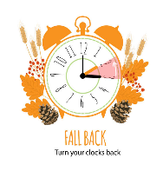

1 Pat Short
2 Nancy Lee
Emily V.
Fernandez
3 Michael McGlothlin
6 Kirsten Bell
Tim Crist
Dennis Tolley
7 Kenny Busic
Cheryl Powell
9 Owen Stinnette
Jeremey
VandeBogart
11 Landen Glass
12 Camden Mason
14 Wade Ware
16 Burton Brooks
Terry Palazzi
Anne-Elaine Tiller
17 Suzanne
Marshall
Blake Phillips
18 Sharon
Rickmon
19 Connie Yost
20 Erin Ecklund
21 Steven Kinzer
22 C.O. Bell
25 Frankie
Hardwick
28 Jacqueline Busic
Cheryl Thomas
29 Wes Robbins
Ricky Smith
31 Robert Baunach

2022
March 2022
Daylight Saving Time ends on Sunday, November 2nd. Remember to FALL back one (1) hour on Saturday evening, November 1st.




*Angel Tree
*Mitten Tree Trunk
*Decorating Church For Christmas
*Christmas Eve Candlelighting-
Worship Service
*Estimate of Giving 2026
(Cards will be available at church or request by mail.)
***Information on all events will be provided in upcoming bulletins!



GOOD NEWS will be published quarterly. Pick up your copy in the Commons or watch for it on our website: www.chestnuthillumc.net.

~Those Who Serve ~
OCTOBER GREETERS
October 5 ~Mary Walker
October 12 ~Maggie Musgrove
October 19 ~Dan Robertson
October 26 ~Ann Robbins

NOVEMBER GREETERS
November 2 ~Betty Taylor
November 9 ~Jane White
November 16 ~Mary Walker
November 23 ~Judy Robertson
November 30 ~Maggie Musgrove

DECEMBER GREETERS
December 7 ~Dan Robertson
December 14 ~Betty Taylor
December 21 ~Jane White
December 28 ~Ann Robbins

Our Church Financial Picture
Through the end of September 2025
General Operating Funds:
Needed to meet our 2025 Budget $ 200,803
Needed to meet our budget to date $ 150,602
Actual receipts to date $ 108,048
Shortage to meet budget to date $ 45,054
Actual expenditures to date $ 117,423
Shortage to meet expenses to date $ 9,375
Special Offerings* (not budgeted):
Received to date $ 8,820
Dispersed to date $ 6,330
*Christmas, Easter, Annual Conference,
World Communion, etc.
Thank you for your generosity.

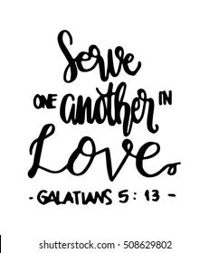

Birthdays…

December
Birthdays
1 Ron Hood
6 Jennifer Jessen
10 Ann Compton
13 Heather Stewart
16 Glenn Collins
17 Chris Glass
Susan Putnam
18 Linda Stables
21 Rev. Becky Cloud
22 Neta Pearson
Jane White
23 Linda Jessen
Loretta Mayhew
Shaman Sunderland
29 Cookie Fish

November Birthdays
1 Jessica Robbins
5 Christopher Palazzi
8 Karsen Burgess
9 Sylvia Glass
10 Elizabeth Ashworth
11 Casey Fish
13 Pat Moore
14 Kathleen Baker
Jane Hood
16 Maggie Musgrove
17 Frank Stewart
24 Ann Ruhland
25 D’Lynn Burgess
26 Ella Dunn
28 Tad LeFew, III
October Birthdays
1 Pat Short
2 Emily V.
Fernandez
7 Kenny Busic
9 Owen Stinnette
Jeremey
VandeBogart
11 Landen Glass
12 Camden Mason
16 Burton Brooks
Terry Palazzi
Anne-Elaine Tiller
20 Erin Ecklund
28 Jacqueline Busic
29 Wes Robbins



DIRECTORY OF
CHESTNUT HILL UNITED METHODIST CHURCH
 | Sue Haupert-Johnson | Richmond Area Resident Bishop
 | Rev. Dr. Sarah Calvert | Mountain View District Superintendent
 | Adam White | Minister
 | Monica Campbell | Administrative Assistant
 | Sharon Mayhew | Director of Music Ministry
 | Judy Martin | Bookkeeper
 | Judy Robertson | Lay Leader
 | Elizabeth Nichols | Missionary in Henry County


Calendar of Events
Sundays—Sunday School, 9:30 a.m. ~ Worship Service, 10:30 a.m.
Fridays –Homeschool, 10:00 a.m.
October
Friday, October 10 ~Church Office Closed
Monday, October 13 ~Columbus Day, Church Office Closed
~Wesleyan Group @ Jessen Home, 7:00 p.m.
Tuesday, October 14 ~Homeschool Game Night, 7:00 p.m.
Saturday, October 18 ~Homeschool Anniversary Party
Sunday, October 19 ~Choir, 10:00 a.m.
Thursday, October 23 ~Merry Marthas Circle, 10:30 a.m.
~Homeschool Costume Party Set-Up, 2:00 p.m.
Friday, October 24 ~Homeschool and Halloween Parties, 9:30 a.m.
Sunday, October 26 ~Choir, 10:00 a.m.
November
Saturday, November 1 ~Charge Conference @ Amelon UMC, 2:30 p.m.
Sunday, November 2 ~All Saints Sunday. Daylight Saving Time ends.
Thursday, November 6 ~Homeschool Picture Set-Up, 2:00 p.m.
Monday, November 10 ~Wesleyan Group @ Jane White’s Home , 7:00 p.m.
Tuesday, November 11 ~Homeschool Game Night, 7:00 p.m.
Saturday, November 15 ~Kathleen Baker’s 100th Birthday Party, 2:00 p.m.
Thursday, November 27 & Friday, November 28 ~Thanksgiving Holiday~Church Office Closed
December
Thursday, December 4 ~Homeschool Holiday Party Set-Up, 2:00 p.m.
Friday, December 5 ~Homeschool and Holiday Parties, 9:30 a.m.
Monday, December 8 ~Wesleyan Group @ Charley’s, 6:30 p.m.
Tuesday, December 9 ~Homeschool Game Night, 7:00 p.m.
Friday, December 12 ~Homeschool and Evening Talent Show, 9:30 a.m.
Wednesday, December 24 ~Church Office Closed
~Christmas Eve Candlelight Worship Service, 4:30 p.m.
Thursday, December 25 ~Merry Christmas, Church Office Closed


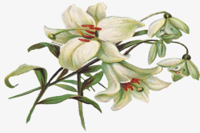

January 2022
2022
April 2022
April 2022
March 2022
Chestnut Hill United Methodist Church
4660 Fort Avenue, Lynchburg, VA 24502

Phone Number: 434-239-8423: FAX: 434-239-7209
E-mail: chestnuthillumc@comcast.net
On the web: www.chestnuthillumc.net

Church Office Hours
Monday-Thursday~9:00 am—3:30 pm
Friday~9:00 am-1:00 pm

